Doprava na shromaždiště v Ylläs

WITHIN EASY REACH

Ylläs is located north of Arctic Circle in Finnish Lapland, in Scandinavia, Northern Europe. Ylläs area consists of two original lappish villages. Äkäslompolo village is located on the northern side of the the Ylläs fell and Ylläsjärvi village on the southern side. Scenery road (Maisematie) connects the villages. The distance between the villages is 15 kilometers. You can reach Ylläs either by air from Helsinki to Kittilä (about 1:30 hours).

Village | Kittilä Airport | Kolari Railway Station | Pajala-Ylläs Airport
Äkäslompolo | 55 km / 50 min | 35 km / 30 min | 85km / 70 min
Ylläsjärvi | 40 km / 30 min | 35 km / 30 min | 85 km / 70 min

Kittilä Airport
1) Bus z letiště Kittila:

The airport buses drive from Kittilä Airport during the season to Äkäslompolo and Ylläsjärvi (from domestic flights). At other times a call taxi should be reserved one day in advance (tel. 0600 14 919, 1,17 EUR/min+pvm).

Stř 12.8. or Čt 13.8.

Kilpisjärvi >>> Kittila
Odj. 11:15 >>> příj. 15:25

2) taxi:

Äkäslompolo
Fare: adults 15,00€/person.
Route: Karila th - Lomakeskus Seita - Ylläshumina - Hotel Ylläskaltio - Äkäshotelli

Ylläsjärvi (Ski resort Iso-Ylläs)
Fare: 13.00€/person.
Route: Ylläs Saaga - Hotel Ylläsrinne - Yllästokka (- Ylläsjärvi Hotel)

Orders and detailed information on transport call 0600 14919 (1,17 € min + local call charge)

3) Doprava autem

The villages of Akäslompolo and Ylläsjärvi are located on opposite sides of Ylläs fell.

Mapa oblasti Kittila – Yllas:

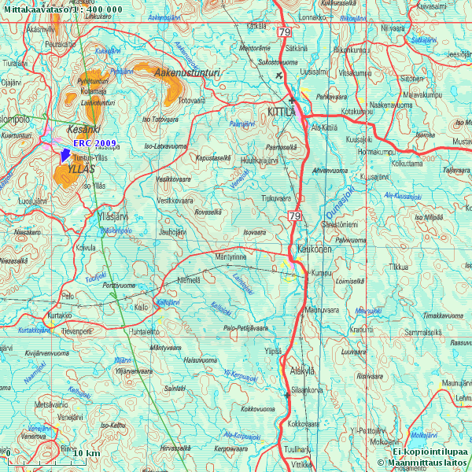

Příjezd do Yllas:

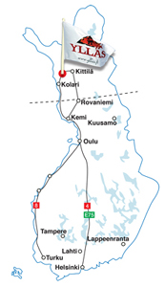 | 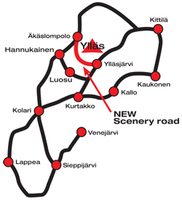
Mapa oblasti Yllas:

