Předzávodní výlet 10. - 13. 8. 2009

nejvyšší bod Finska Halti, největší finský vodopád Pihtususköngäs,
vodopád na řece Kitsijoki, hraniční trojmezí Finsko, Norsko, Švédsko,
nejkrásnější hora Finska Saana

Vzdálenost Kilpisjärvi Kittilä airport 286 km

Mapa trojmezí:

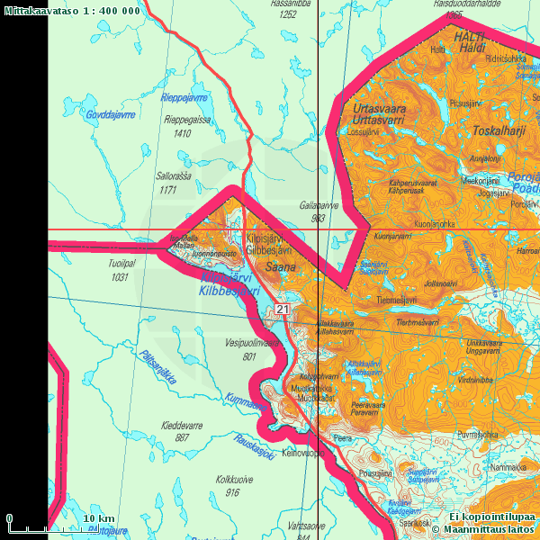

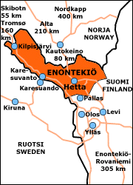 | 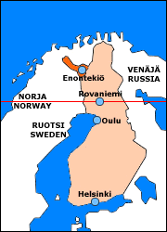

Halti-fell hikes
Five-six day hike to the highest point in Finland, tip of Halti fell in distance of 45 km from Kilpisjärvi, will test your gear and fitness. You will see many wonders of this arctic land during the course of this popular hike: Most notable sights you will come across are the Pitsusköngäs waterfalls and Annjalonji steep stonewalls. Another place worth a mention are the Pitsusjärvi-lake windy and cool rims. Meekojärven pahta is almost a straight wall of stone dropping to Meekojärvi Lake for nearly 200 meters. The Halti-hike is 110 km in length there and back.
If you have the time, its well worth to take a small deviation from the trail. With a little extra walk you get to see a strange figuration of terrain called Saivaara. Close to Termisjärvi is Salmikuru and a more notable place to visit would be Kurrurankuru-hill. From Meekovaara hill you will get a nice view towards Porojärvi-valley.
On top of Halti Fell, you will get to write your name in the "conquerors Halti" - book. At this point the there are around 60000 names written in it.
CLIMBING TO SAANA

Very obvious activity in summer is to conquer Saana. Saana is accessible from the Excursion Centre- side of the fell. Saana trail starts from the yards of the Excursion Centre. You will need to reserve 2 hours minimum to do the climb. More information on the trail to Saana can be found at the starting point of the track.

Výlet na Halti

Trek k Halti (1324m) - nejvyšší hoře Finska (ležící na norské hranici v nejseverozápadnějším výběžku Finska, cca 50 km od nejbližší silnice z osady a od stejnojmenného jezera Kilpisjärvi). Putovali jsme po trase: Kilpisjärvi - Termisjärvi (přespání) - Kuonjarjoki (n) - Meekonjärvi - Pihtsusjärvi (n) - Halti - Pihtsusjärvi (n) - Kopmajoki (n) - Porojärvi (n) - Meekonjärvi - Kuonjarjoki - Saarijärvi (n) - Kilpijsärvi - Ailakkajärvi (n) - Kilpisjärvi.

