Předzávodní výlet 10. - 13. 8. 2009

nejvyšší bod Finska Halti, největší finský vodopád Pihtususköngäs,
vodopád na řece Kitsijoki, hraniční trojmezí Finsko, Norsko, Švédsko,
nejkrásnější hora Finska Saana

Halti-fell hikes
Five-six day hike to the highest point in Finland, tip of Halti fell in distance of 45 km from Kilpisjärvi, will test your gear and fitness. You will see many wonders of this arctic land during the course of this popular hike: Most notable sights you will come across are the Pitsusköngäs waterfalls and Annjalonji steep stonewalls. Another place worth a mention are the Pitsusjärvi-lake windy and cool rims. Meekojärven pahta is almost a straight wall of stone dropping to Meekojärvi Lake for nearly 200 meters. The Halti-hike is 110 km in length there and back.
If you have the time, its well worth to take a small deviation from the trail. With a little extra walk you get to see a strange figuration of terrain called Saivaara. Close to Termisjärvi is Salmikuru and a more notable place to visit would be Kurrurankuru-hill. From Meekovaara hill you will get a nice view towards Porojärvi-valley.
On top of Halti Fell, you will get to write your name in the "conquerors Halti" - book. At this point the there are around 60000 names written in it.
CLIMBING TO SAANA

Very obvious activity in summer is to conquer Saana. Saana is accessible from the Excursion Centre- side of the fell. Saana trail starts from the yards of the Excursion Centre. You will need to reserve 2 hours minimum to do the climb. More information on the trail to Saana can be found at the starting point of the track.

Úterý 11. 8. až středa 13. 8. – výlet na nejvyšší místo Finska Halti (Kilpisjärvi-Halti Trail)

Tam a zpět cca 110 km. Asi bez stanů, přespání ve srubech nebo pod širákem.
The trail crosses over to Finland at Lake Somasjärvi, passes Kilpisjärvi and has its end points at Kvikkjokk in Sweden and at Sulitjelma in Norway. Kilpisjärvi-Halti Trail is about 55 km long. Its starting point is at Kilpisjärvi. From there it heads towards Käsivarsi Wilderness Area crossing over into Norway occasionally. At Lake Pihtsusjärvi the trail parts into two branches, which lead to Lake Somasjärvi and Halti Fell.

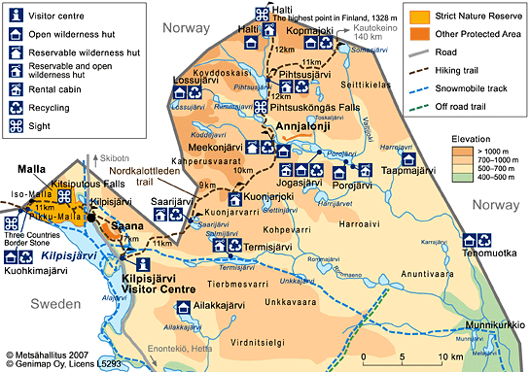
Co potkáte cestou

Saana Fell (1029 m) - nejkrásnější hora Finska, posvátná hora Sámů (1029 m)

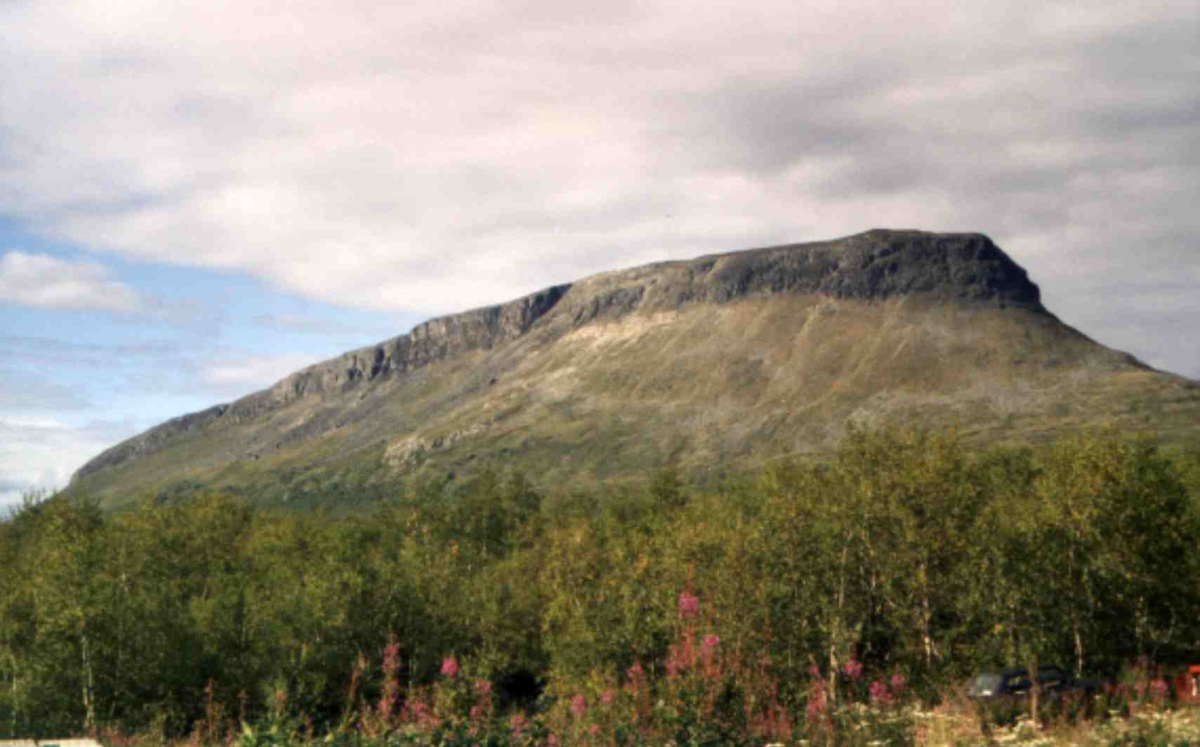

Saivaara Hill

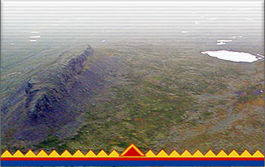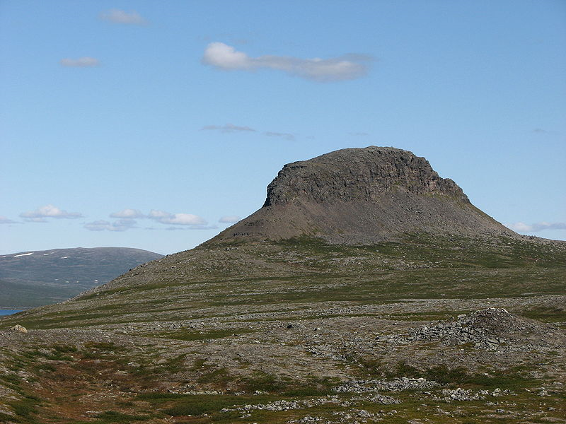

Saivaara is a peculiar looking structure near Meekonjärvi-lake. It can been reached easily by plane to see an aerial view, but is also accessible on foot from the east side during Halti hiking. On top there is a small memorial tablet of Finnish President Kekkonen, who used to do a lot of skiing in his days in these regions.

Pihtsusköngäs Falls - největší finský vodopád, 17 metrů vysoký. Na prvních 2 fotkách teda vypadá jak Niagara :-).

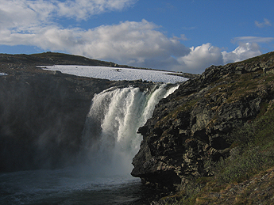

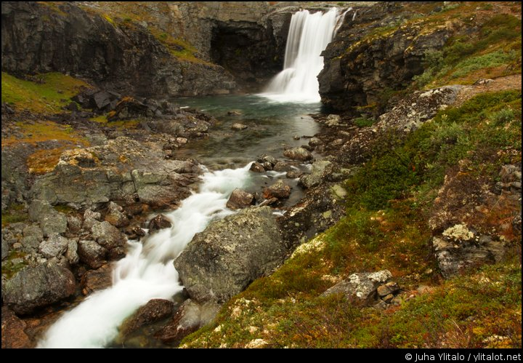

Halti Fell (nejvyšší bod Finska 1324 m)

Halti 1 365 m
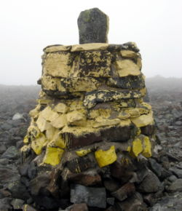
Hraniční kámen na nejvyšším místě Finska (1324 m)

Pod jedním z výběžků hory Háldečohkka (1331 m n. m.) se nachází nejvyšší bod Finska (1324 m n. m.). Vrchol hory Halti 1365 m leží v Norsku a nazývá se Ráisduattarháldi. Nejvyšší hora, jejíž vrchol leží ve Finsku, je Ritničohkka (1316 m).
Sruby na přespání (zdarma/placené)

1) Saarijärvi Open Wilderness Hut (11. kilometr)

Open wilderness hut for 10 persons near the Norwegian border, on the north of the Salmivaara Fell at the west end of Lake Saarijärvi. A stove and a gas cooker. There are waste bins at the hut, but hikers are adviced to bring their own waste out of the area. Reservable wilderness hut for 10 persons.

2) River Kuonjarjoki Open Wilderness Hut (20. kilometr)

Open wilderness hut for 10 persons on the south of the Kahperusvaara hilus, on the north bank of the River Kuonjarjoki which runs between the Kahperusvaara Hills and Guonjarvárri Fell. A stove and a gas cooker.
There are no waste bins at the hut!!! Reservable wilderness hut for 10 persons.

3) Lake Meekonjärvi Open Wilderness Hut (30. kilometr)

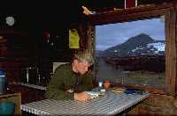

Open wilderness hut for 6 persons, on the southeast bank of the River Pierfejoki, which runs into the sound at the west end of Porojärvi Valley between Lake Meekonjärvi and Lake Skadjajärvi. It is about 500 metres from the mouth of the river. A stove and a gas cooker. There are waste bins at the hut, but hikers are adviced to bring their own waste out of the area. Reservable wilderness hut for 10 persons.

4) Lake Pihtsusjärvi Open Wilderness Hut (42. kilometr)

Open wilderness hut for 10 persons, on the east shore of Lake Pihtsusjärvi on the north side of the River Rassajapuro. Reservable wilderness hut for 10 persons.

5) Halti Fell an old Open Wilderness Hut (54. kilometr)

Open wilderness hut for 5 persons, on the west shore of the lake which is on the south side of Haltitunturi Fell. It is approximately 1,5 km from Nordkalottleden Trail. A stove and a gas cooker. There are waste bins at the hut, but hikers are adviced to bring their own waste out of the area. About 300 metres from this hut is a building which houses a newer open wilderness hut (8 persons) as well as a reservable wilderness hut (13 persons).

6) River Kopmajoki Open Wilderness Hut (11 km mimo trasu)

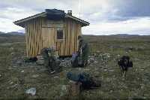

Open wilderness hut for 6 persons, situated on the west side of Seitalompolo on the bank of the River Kopmajoki. A stove and a gas cooker. There are waste bins at the hut, but hikers are adviced to bring their own waste out of the area.

